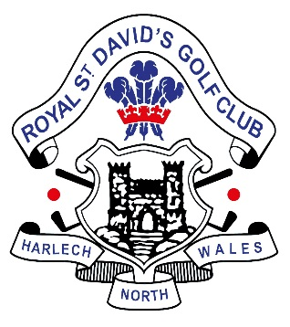

St. David’s Gold Cross Reserve List 2021

|  |  |
| --- | --- |
| 1 | Jack Coleman |
| 2 | Neil Hargreaves |
| 3 | Kieran Ashton |
| 4 | Charley Simpson |
| 5 | Elfyn Griffiths |
| 6 | Ethan Ives |
| 7 | Justin Courtnage |
| 8 | Joss Lerwill |
| 9 | Alexander Weir |
| 10 | Daniel Cawley |
| 11 | John Shuttleworth |
| 12 | Lee Dalgleish |
| 13 | Adrian Collins |
| 14 | James Dawson |
| 15 | Christopher Cummins |
| 16 | Roy Edwards |
| 17 | George Dears |
| 18 | Spencer Jackson |
| 19 | Jac Roscoe |
| 20 | Tom Peet |
| 21 | Sam Peet |
| 22 | Alex Japp |
| 23 | Joseph M Jones |
| 24 | Adam Partington |
| 25 | Luke Nedza |
| 26 | Harry Frazer |
| 27 | Steffan Evans |
| 28 |  |